8.27: Denote the final speeds as 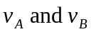and the initial speed of puck A as 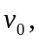 and omit the common mass. Then, the condition for conservation of momentum is

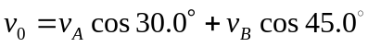
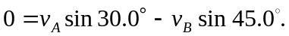

The 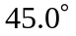 angle simplifies the algebra, in that sin 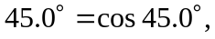and so the 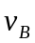terms cancel when the equations are added, giving

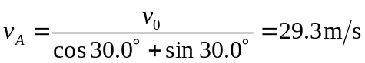
From the second equation, 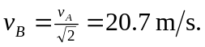 b) Again neglecting the common mass,

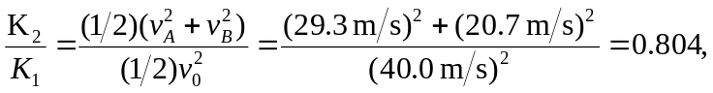

so 19.6% of the original energy is dissipated.

